NAME : MD ZABED KHAN AGE : 45 YRS/ M
Refd. By DR.: DR.: K SASIKUMAR DNB(ORTHO), FIPM DATE OF REPORT: 4 February 2026
==============================================================================

MRI LUMBAR WITH SCREENING OF DORSAL & CERVICAL SPINE
Study: MRI Lumbar Spine with screening of dorsal and cervical spine
Sequences: T1, T2, STIR

Cervical Spine (Screening)
- Loss of cervical lordosis.
- Disc dessication noted at multiple cervical levels.
- Mild disc bulge at C4–5, C5–6, and C6–7 with minimal anterior thecal sac compression.
- No significant cord signal abnormality.
- No gross vertebral collapse or fracture.

Dorsal Spine (Screening)
- Mild hypertrophy of posterior longitudinal ligament (PLL).
- No significant disc herniation or cord compression.
- Vertebral body heights maintained.
- No abnormal marrow signal.

Lumbar Spine

Alignment & Curvature
- Loss of lumbar lordosis.

Vertebral Bodies
- L1 vertebra: anterior height = 20.2 mm, posterior height = 26.8 mm.
- L3 vertebra: vertebral hemangioma.
- Remaining vertebral body heights maintained.
- No acute fracture.

Intervertebral Discs
- L4–L5: Reduced disc space with endplate sclerosis. Signal changes: T2 hyperintense, STIR hyperintense, T1 hyperintense.
- L2–L3: Mild diffuse disc bulge with mild central protrusion.

- L3–L4: Diffuse disc bulge with posterior annular tear and central protrusion, causing:
  - Anterior thecal sac compression
  - Compression of bilateral traversing nerve roots
  - Bilateral neural foraminal stenosis
- L5–S1: Disc morphology preserved.

Posterior Elements
- Ligamentum flavum hypertrophy at L2–3, L3–4, L4–5, and L5–S1.
- Facet joint hypertrophy at L2–3, L3–4, L4–5, and L5–S1.

Spinal Canal (SC dimensions in mm)
- L1–2: 14.2
- L2–3: 11.2
- L3–4: 6.1 (severe canal narrowing)
- L4–5: 10.9
- L5–S1: 13.6

Impression
- Loss of cervical and lumbar lordosis.
- Cervical spine: Disc dessication with mild bulges at C4–5, C5–6, and C6–7 causing minimal anterior thecal sac compression.
- Dorsal spine: Mild PLL hypertrophy, no significant cord compression.
- Lumbar spine:
  - Degenerative disc disease at L4–5 with endplate sclerosis and altered signals.
  - Severe canal stenosis at L3–4 (SC diameter 6.1 mm) with annular tear, central protrusion, anterior thecal sac compression, bilateral traversing nerve root compression, and bilateral foraminal stenosis.
  - Mild diffuse disc bulge at L2–3.
  - L3 vertebral hemangioma.
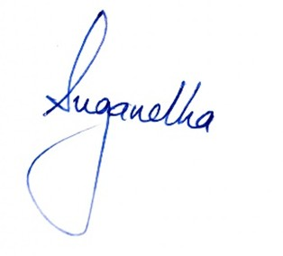
  - Multilevel posterior element hypertrophy (ligamentum flavum and facet joints) from L2–S1.

